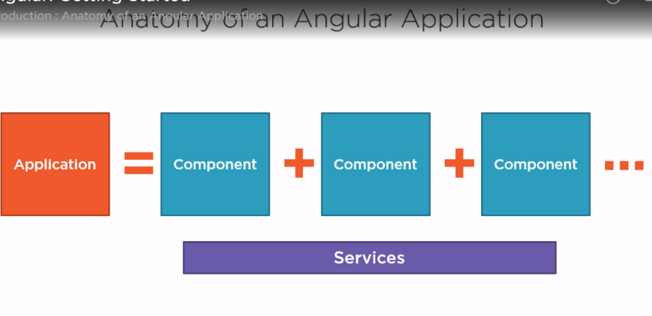Angular application comprised with a set of *components* and a set of *services* that provide functionality across those components.

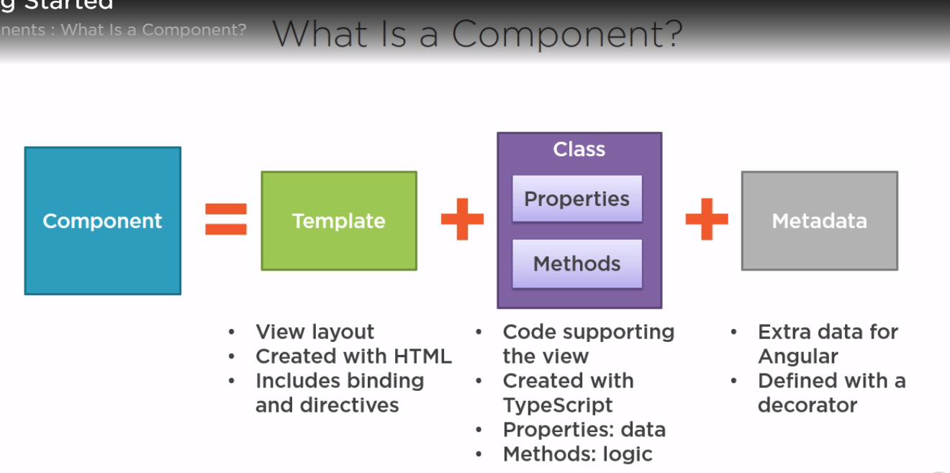

What is a component?

A *view* defined with a *template*(HTML),it’s associated code defined with a *class* and additional information defined with *metadata*

What is a module?

A module is a collection of services, directives, controllers, filters, and configuration information.

AngularJs has modules used to *organize code* *and resolve namspacing* issues

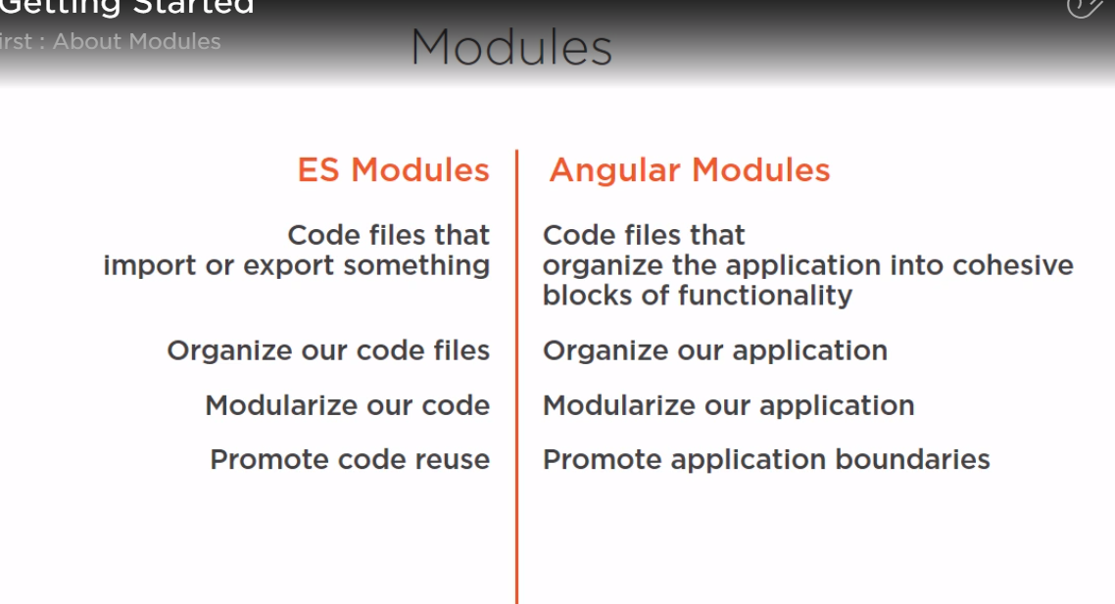

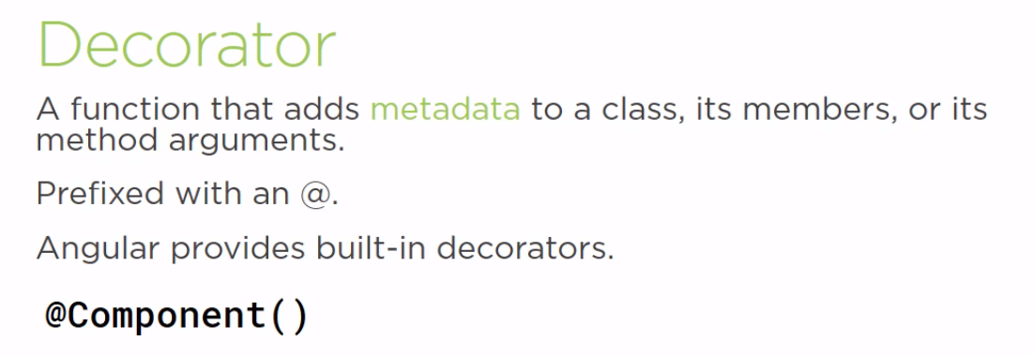

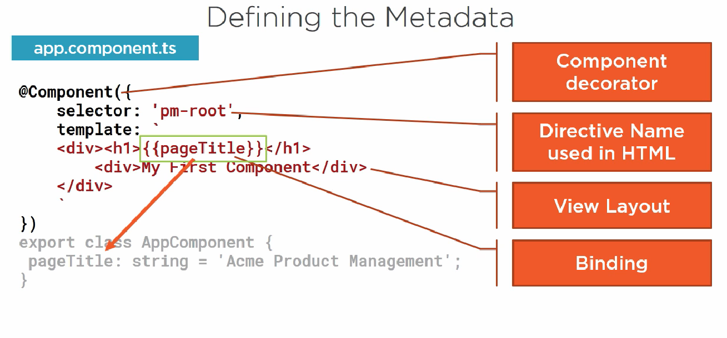

What is a *Directive*?

Custom HTML element or attribute used to power up and extend our html.

. Custom

.Built-in

